Captcha Recognition Using CNN

To train Captcha CNN model we have used Captcha images and then build a recognition model and this model can be used to predict Captcha from new test images. To train model we have preprocess each image by converting it into Grey Scale and then normalized all pixels data. Below is the dataset screen shots used to train this model

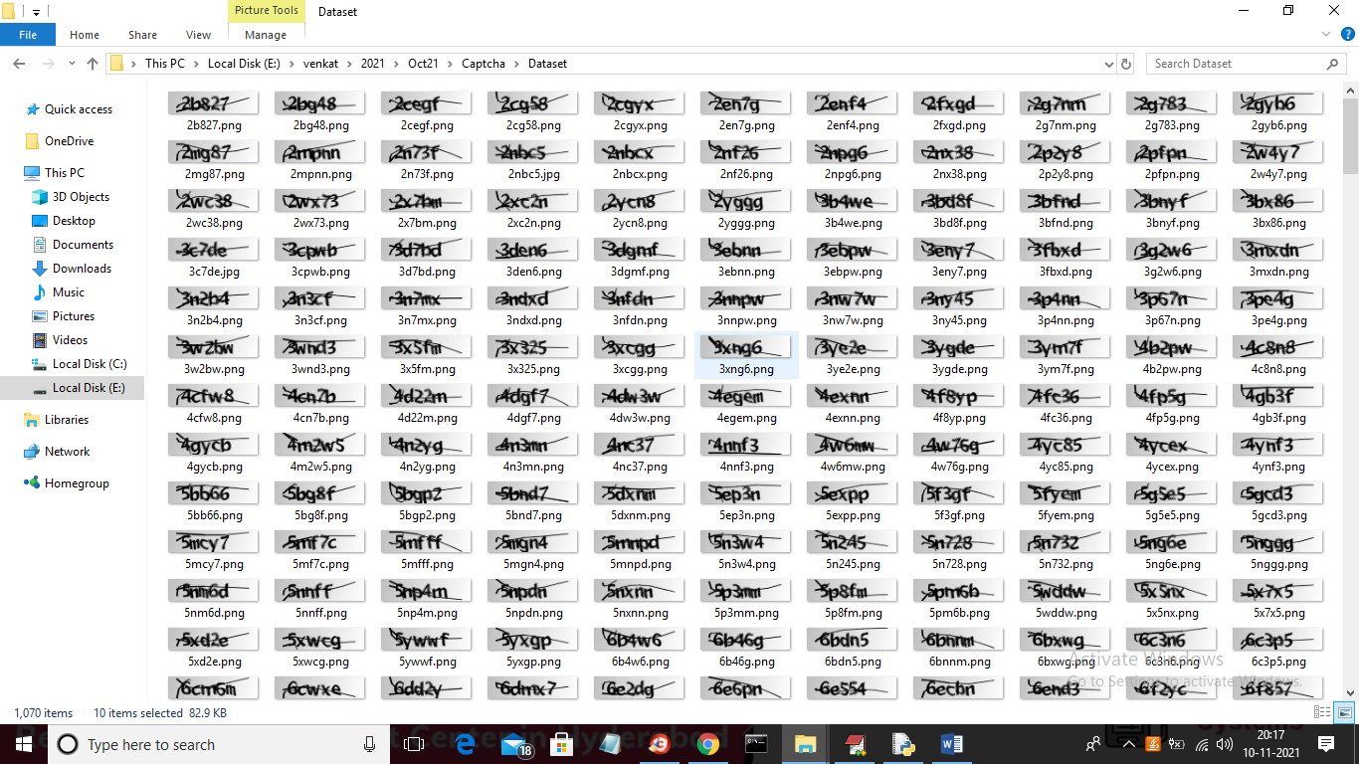

Above images can be used to train CNN.

SCREEN SHOTS

To run project double click on ‘run.bat’ file to get below screen

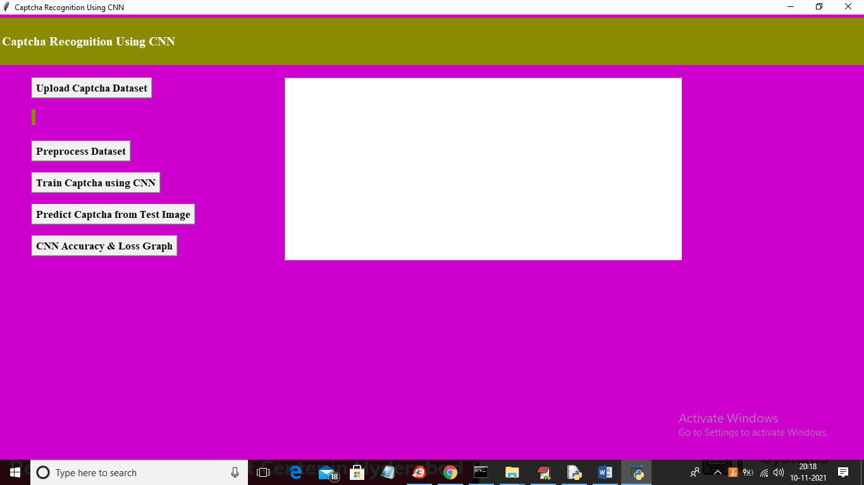

In above screen click on ‘Upload Captcha Dataset’ button to upload dataset and to get below screen

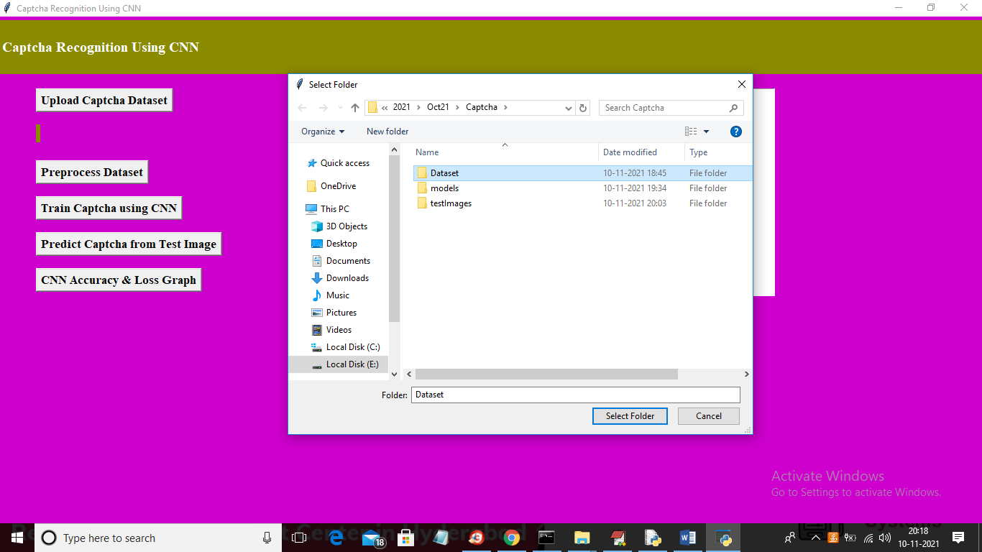

In above screen selecting and uploading ‘Dataset’ folder and then click on ‘Select Folder’ button to load dataset and to get below screen

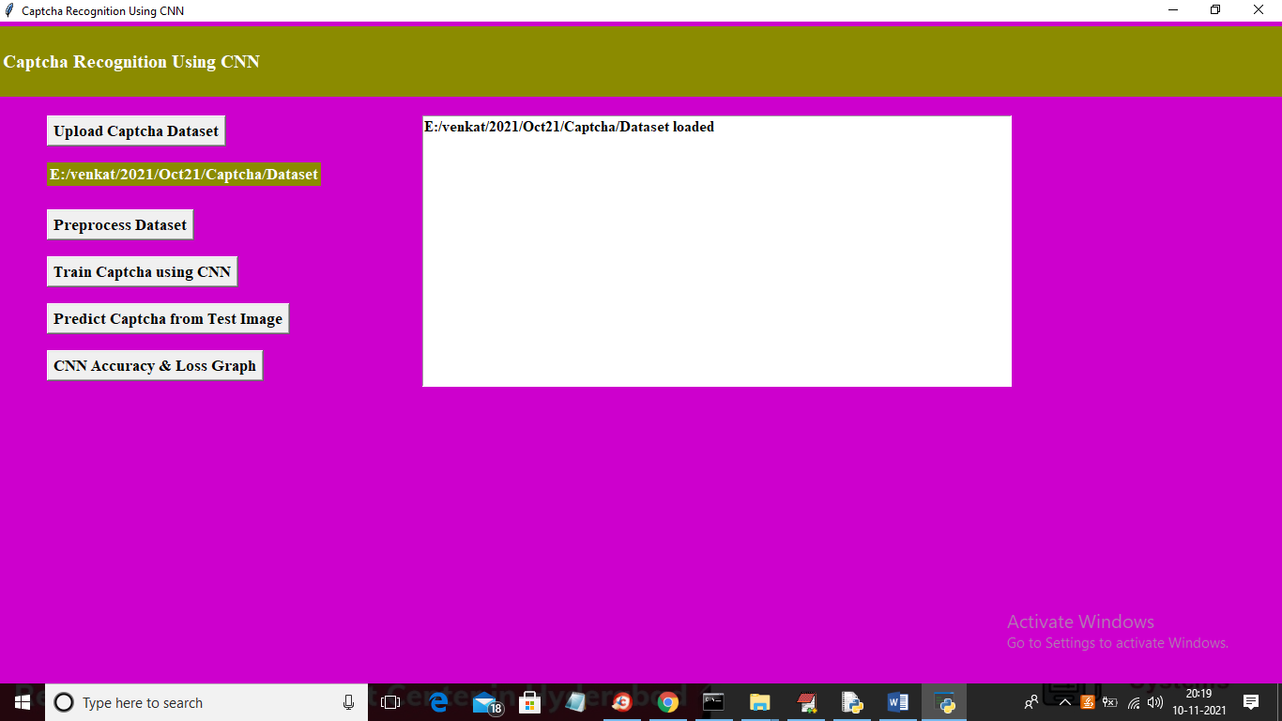

In above screen dataset loaded and now click on ‘Preprocess Dataset’ button to process all images and to get below screen

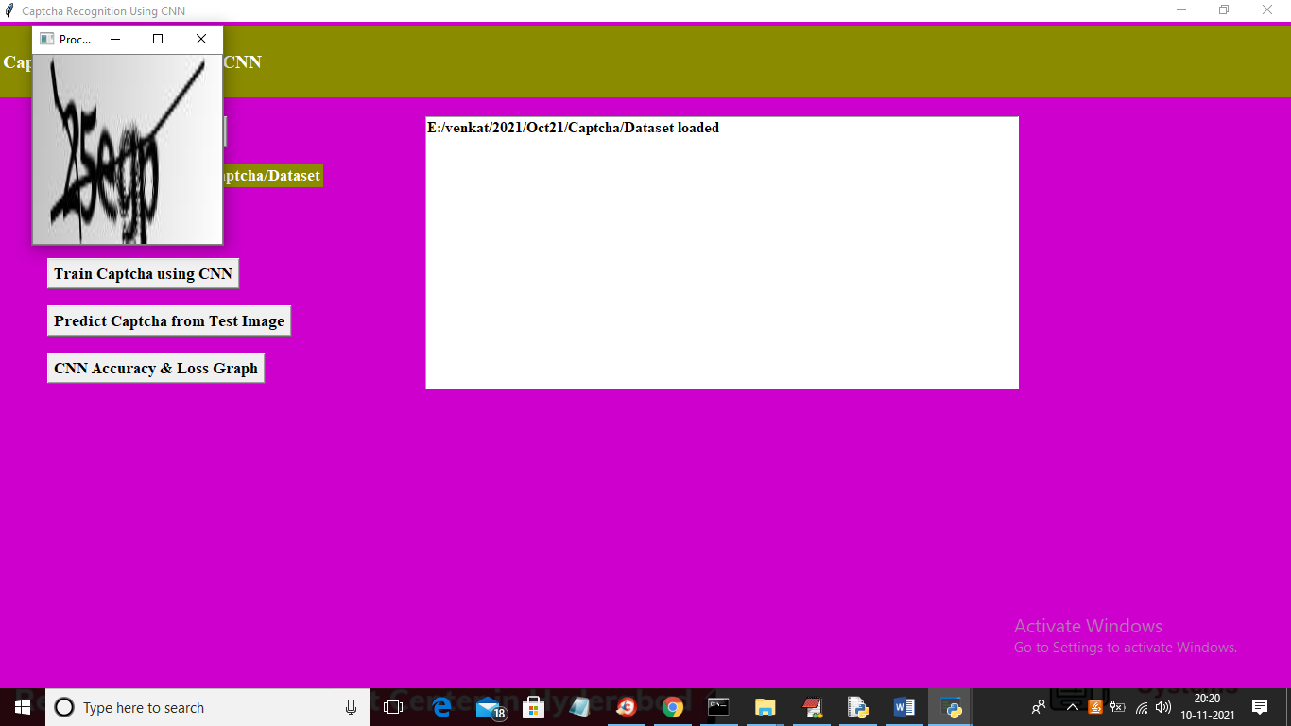

In above screen displaying sample grey scale normalized image and then close above image to get below output

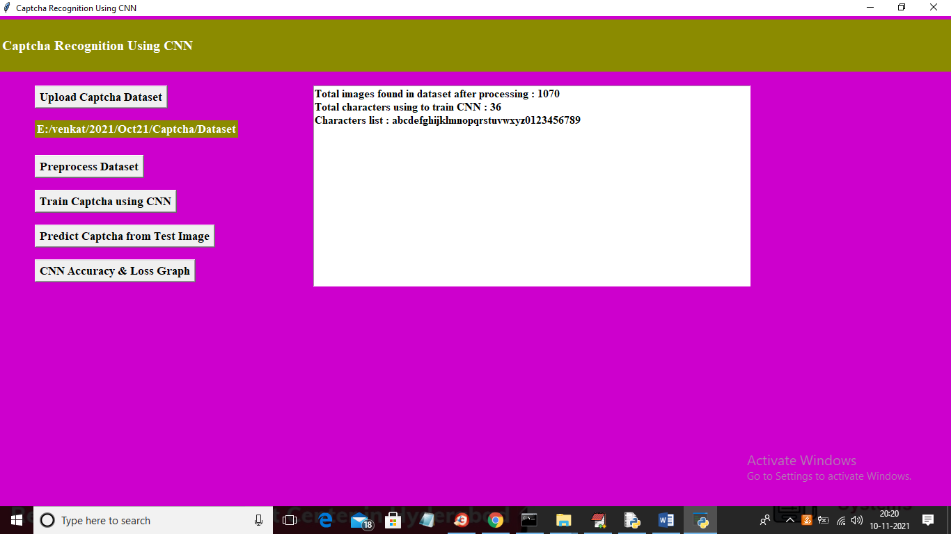

In above screen we can see total dataset images and characters used to train CNN model. Now dataset is ready and now click on ‘Train Captcha using CNN’ button to train CNN model and calculate loss value

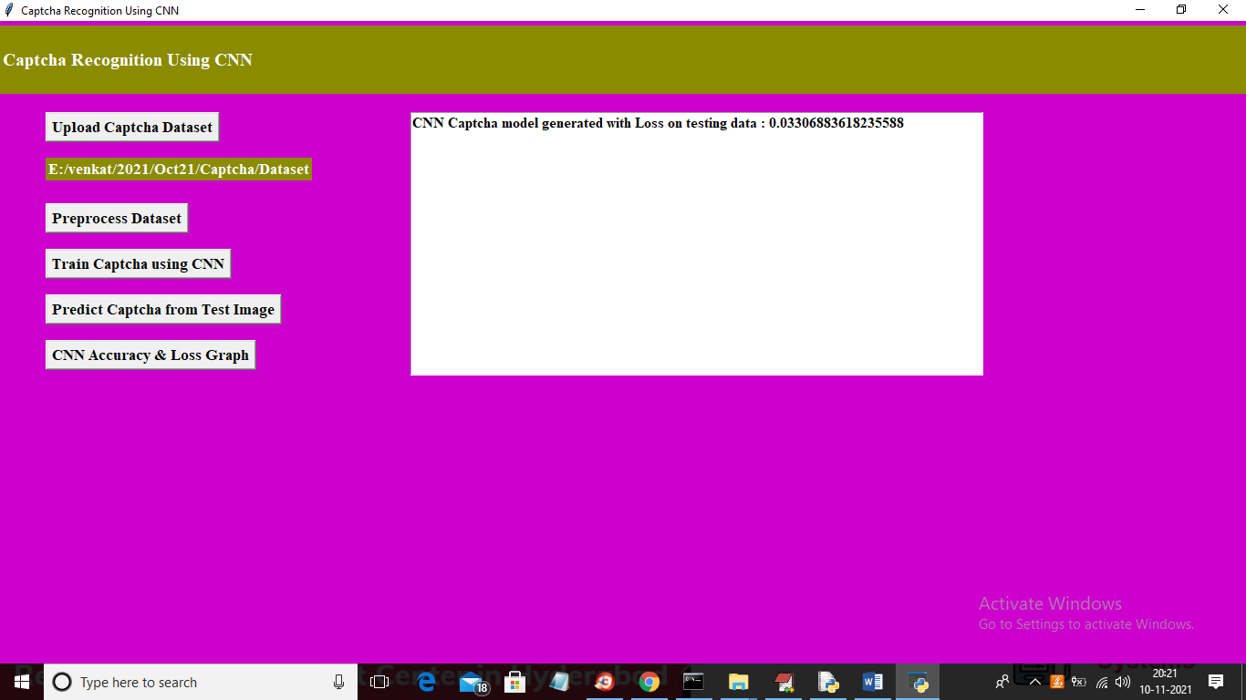

In above screen we got CNN loss value as 0.033 so accuracy will be 100 – 0.033 = 99.967 and now model is ready and now click on ‘Predict Captcha from Test Image’ button to upload test image like below screen

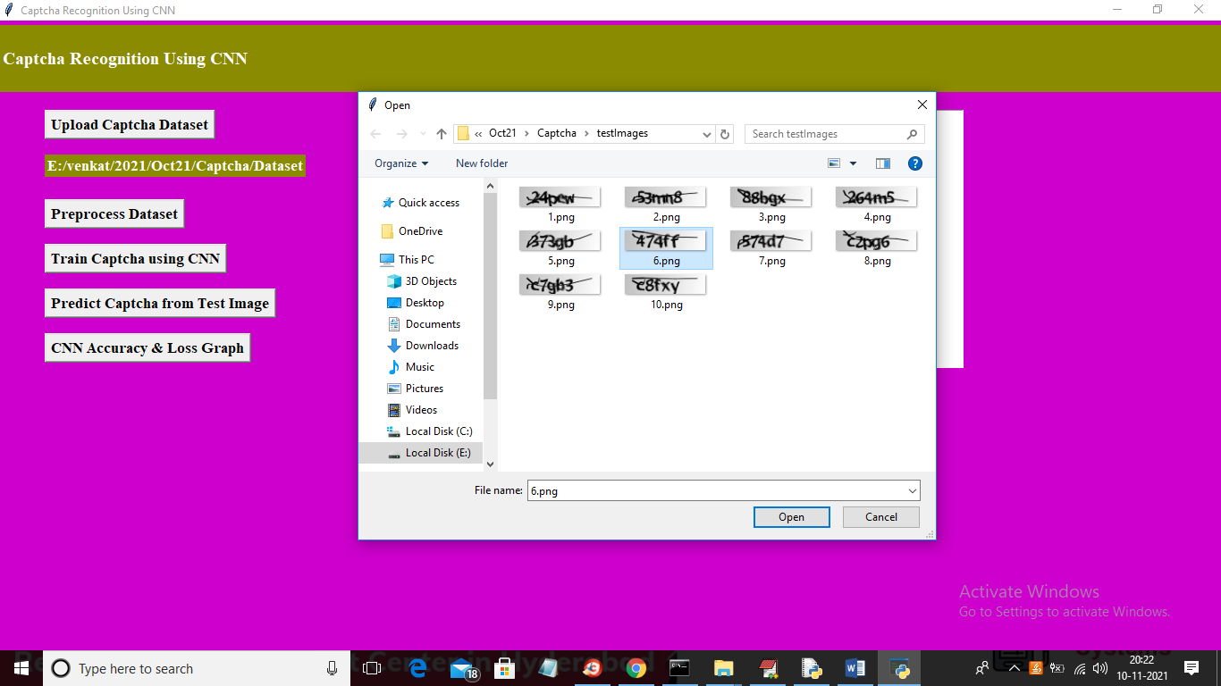

In above screen selecting and uploading ‘6.png’ image and then click on ‘Open’ button to get below output

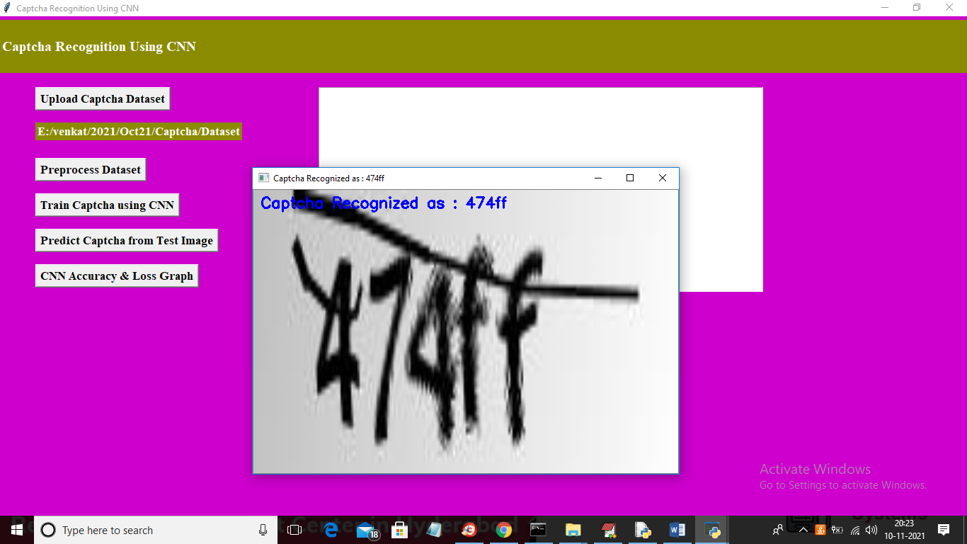

In above screen Captcha is recognized as ‘474ff’ and similarly you can upload other images and test them. Now close above image and then click on ‘CNN Accuracy & Loss Graph’ button to get CNN training performance

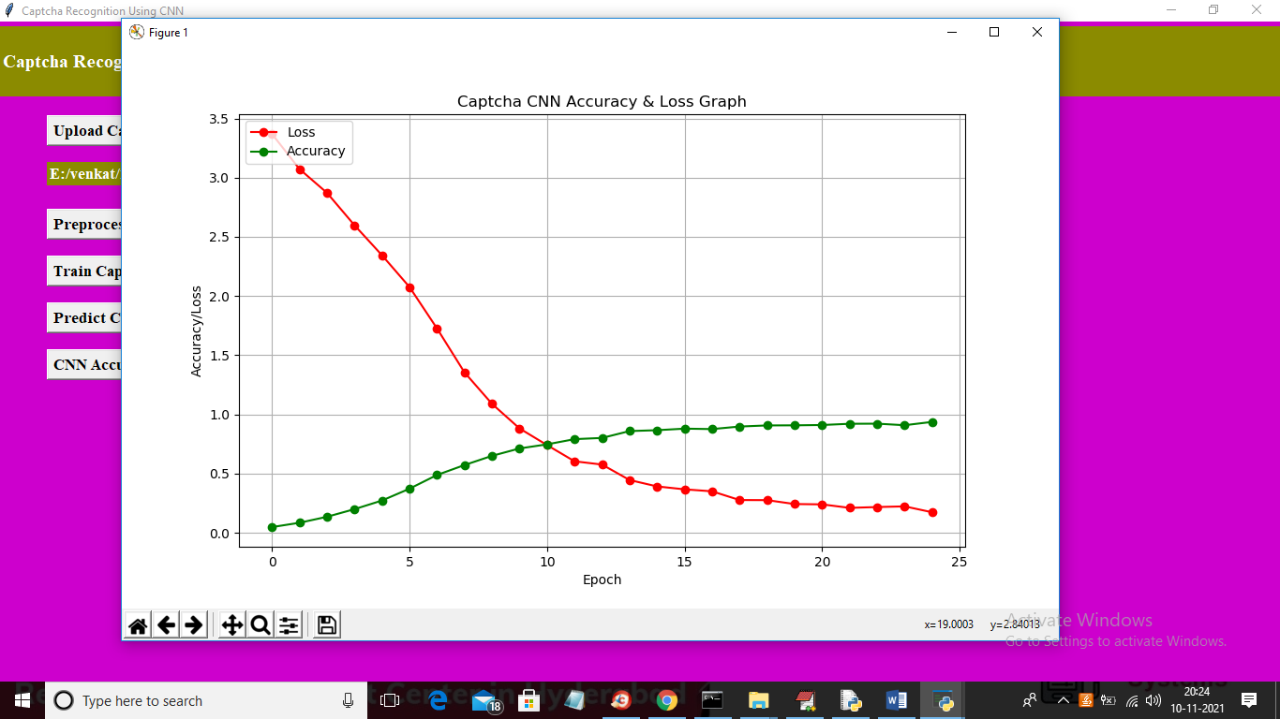

In above graph x-axis represents EPOCH and y-axis represents accuracy/loss values and in above graph red line represents LOSS and green line represents accuracy and in above graph we can see with each increasing epoch accuracy value got increased and loss values got decreased which indicates CNN trained accurately on dataset.